GitHub – Pull File

T Godwin Abilash – 192321012

**Set Up Git**

* Install [Git](https://git-scm.com/downloads) on your system if not already installed.
* Configure Git with your username and email:

git config --global user.name "Your Name"

git config --global user.email "youremail@example.com"

git init

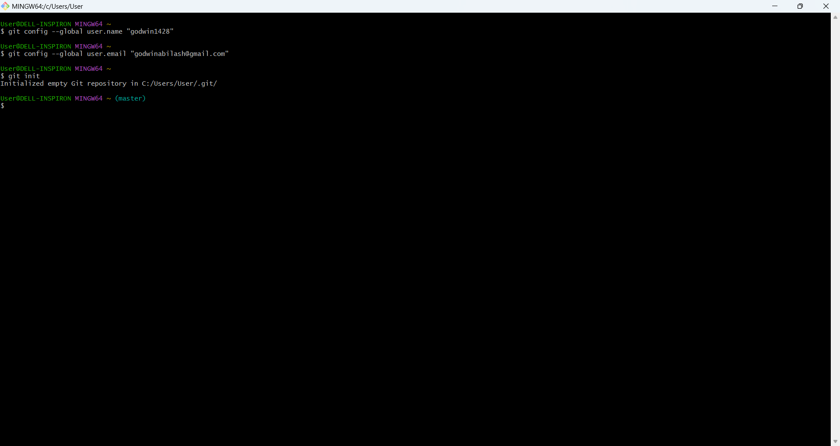

1. Choose an Existing GitHub Repository

1. Visit a public repository on GitHub
2. Copy the repository's HTTPS URL:
   * On the repository page, click the green "Code" button and copy the URL (e.g., https://github.com/octocat/Hello-World.git).

2. Clone the Repository

1. Open a terminal/command prompt.
2. Navigate to the directory where you want to clone the repository:

cd demose

1. Clone the repository:

git clone https://github.com/octocat/Hello-World.git

1. Navigate into the cloned repository directory:

cd sepractical

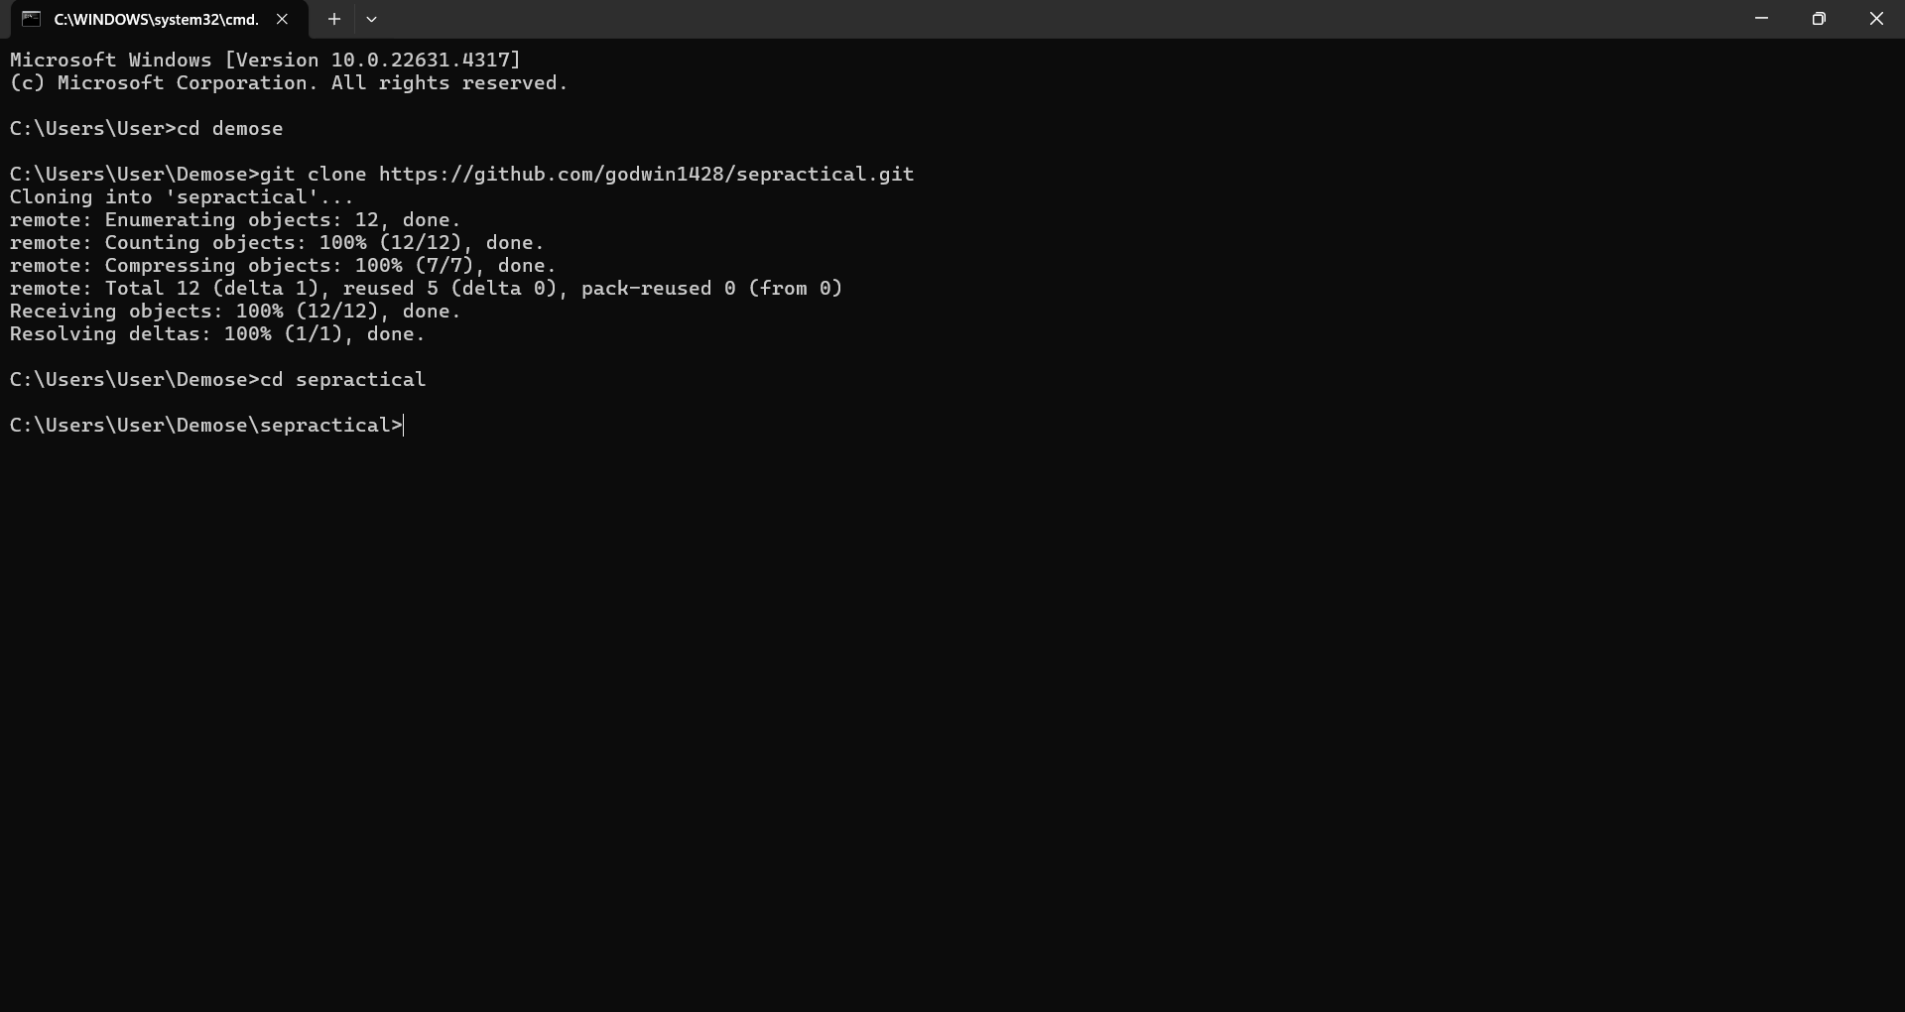

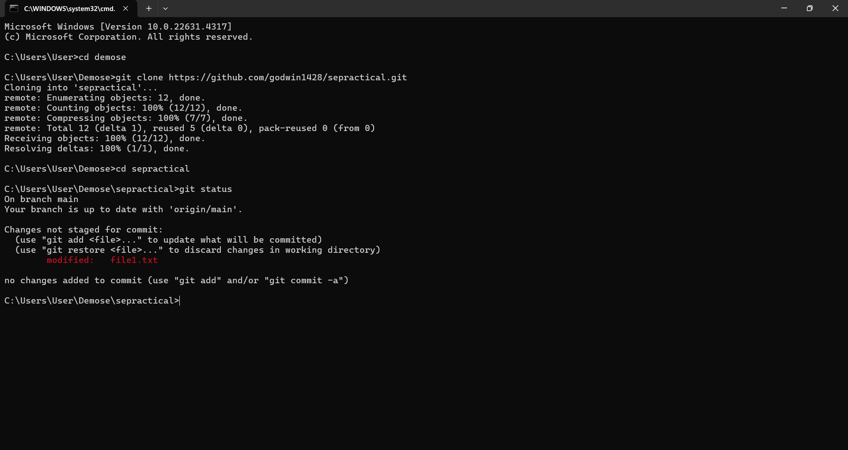

**Collaborator Makes Changes**

1. Ask your collaborator to:
   * Make changes to the repository (e.g., edit the README.md or add a new file).
   * Push their changes to the repository.

**3. Pull the Latest Changes**

1. In your local repository, run the following command to pull the latest changes:

git pull origin main

* + origin: Refers to the default remote name for the repository.
  + main: Refers to the branch you’re pulling from (replace with the correct branch name if different).

1. If successful, the terminal will display the changes that were pulled.

